1. INTRODUCTION
   1. Overview

Find the right template .choose from hundreds of

Professionally -designed resume templates.

1.2 PURPOSE

Help you remember important sections to include ,

Give you good examples ,and help your thoughts

Flow when you’re stuck.

1. Problem Definition & Desiging Thinking
   1. Empathy map

Paste the empathy map screenshot.

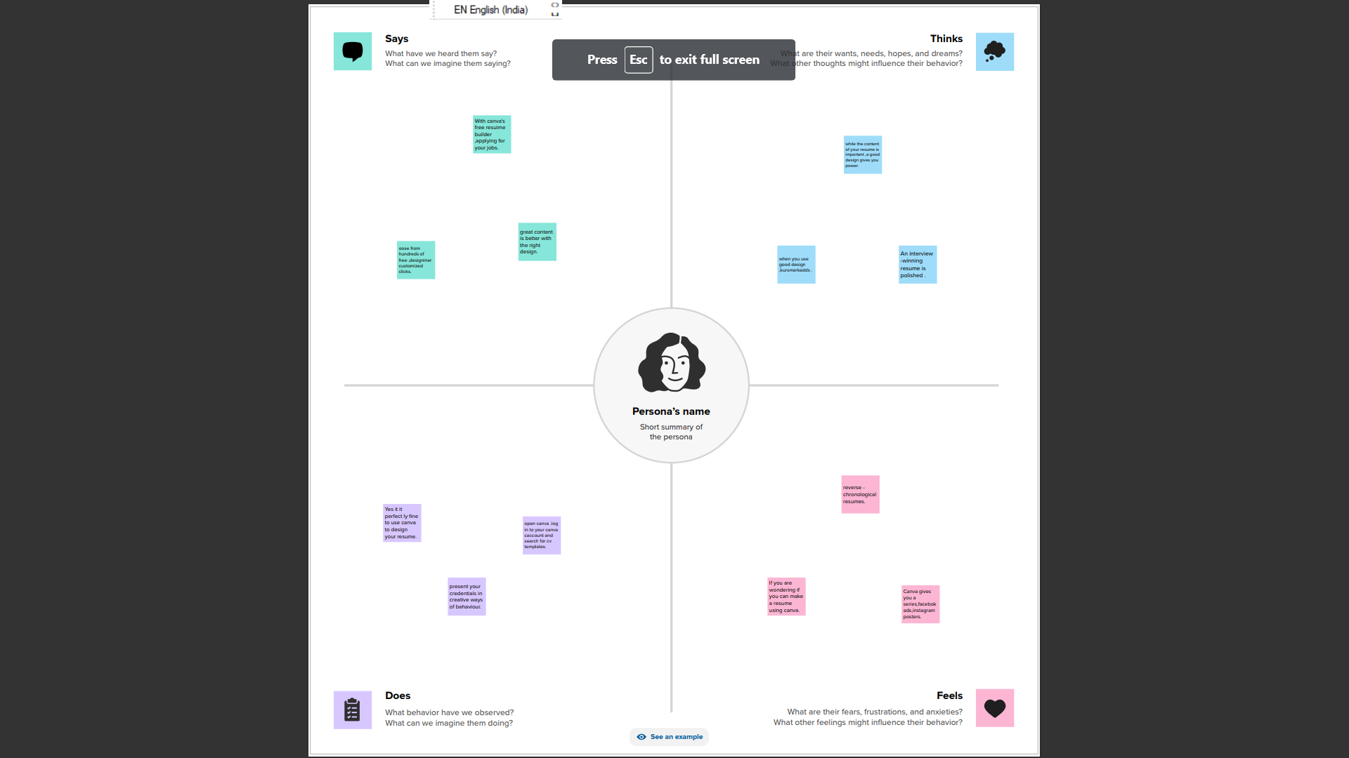

* 1. Ideation & Brainstorming map screenshot

Paste the ideation & brainstorming map screenshot

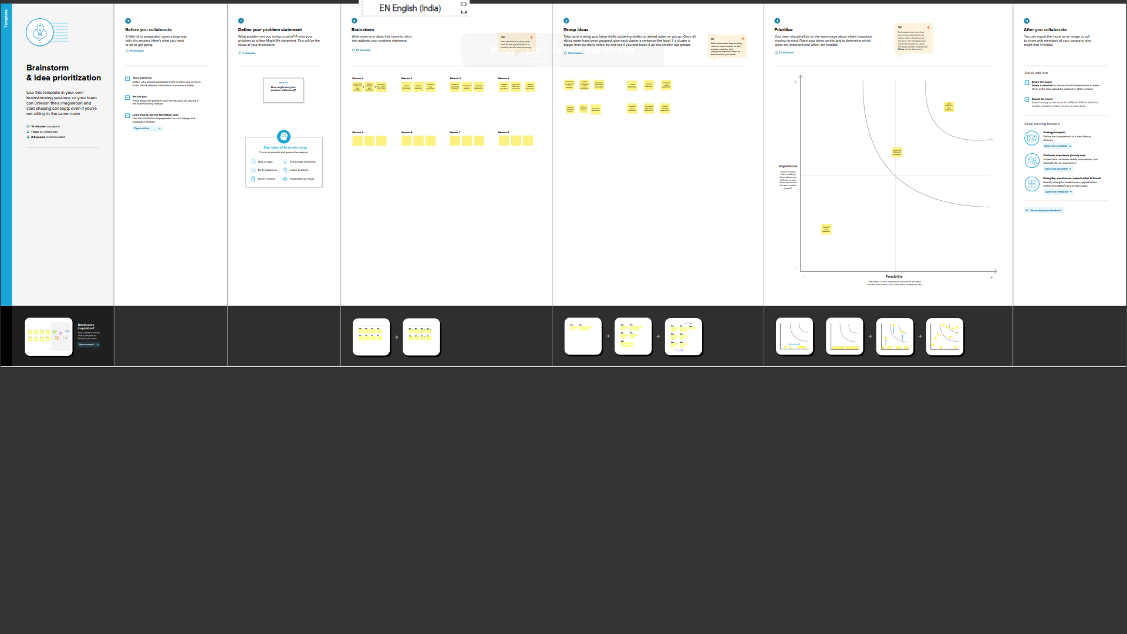

1. RESULT

Final flindings (output )of the project along with screenshot

````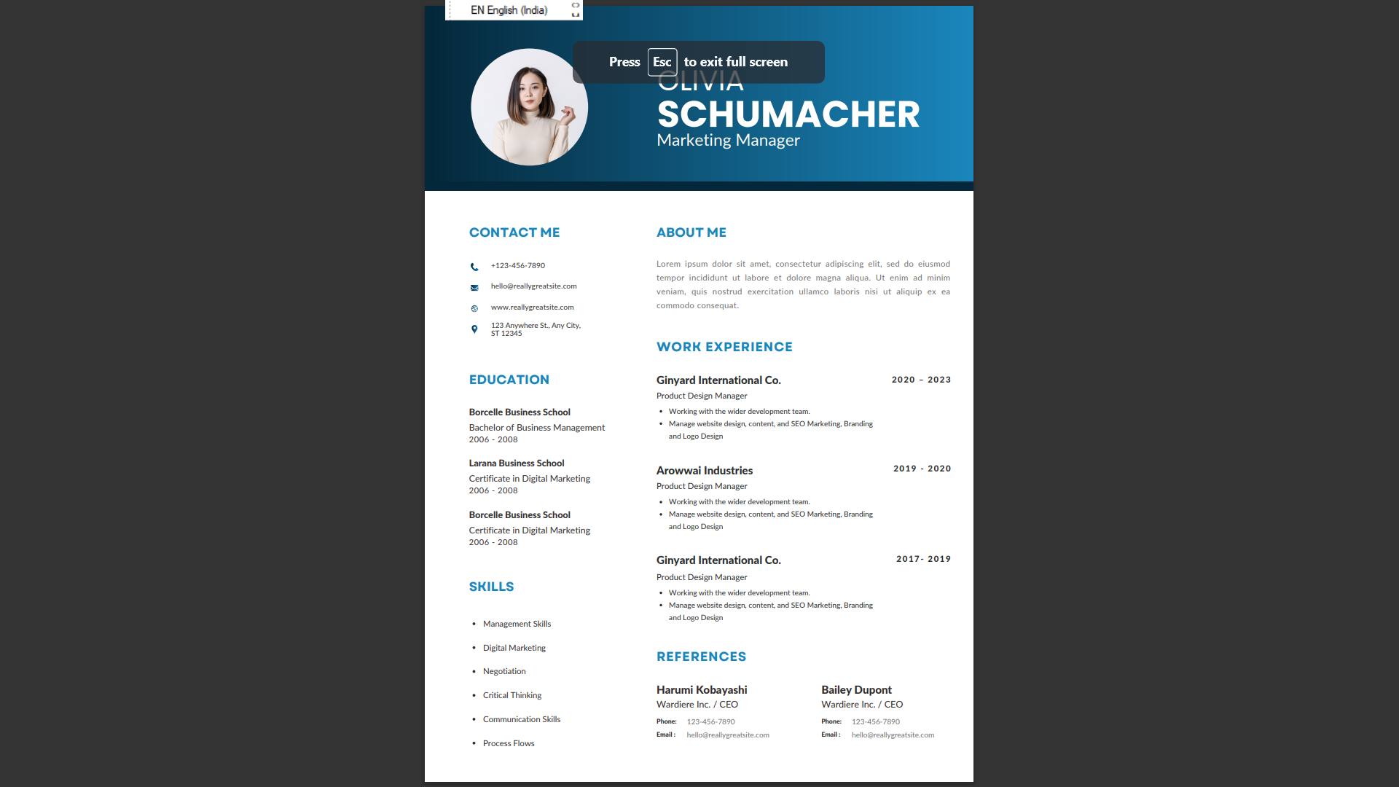

1. ADVANTAGES & DISADVANTAGES
2. Students can use Canva to construct and show knowledge.
3. They can also capture photos or videos of their class wok.
4. Canva is that it can limit creativity.
5. The platform operates on a drag-and-drop basis.
6. APPLICATION

An itemized list of a person’s entire education ,publications

Accomplishments ,notable projects,awards,honors,achievements.

1. CONCLUSION

You’re better off working with a professional resume writer who

Knows the ins and outs of resume design.